# PEN AND PAPER ASSIGNMENTS

Mike Pingel – s1752065 – Ernst de Vries –

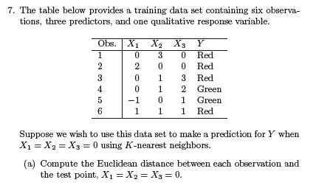**2.1.)**



**2.1.a.)**

|  |  |  |  |
| --- | --- | --- | --- |
| X1 | X2 | X3 | Square distance to query point |
| 0 | **3** | **0** | **(0-0)^2 + (3-0)^2 + (0-0)^2 = 9** |
| 2 | **0** | **0** | **(2-0)^2 + (0-0)^2 + (0-0)^2 = 4** |
| 0 | **1** | **3** | **(0-0)^2 + (1-0)^2 + (3-0)^2 = 10** |
| 0 | **1** | **2** | **(0-0)^2 + (1-0)^2 + (2-0)^2 = 5** |
| -1 | **0** | **1** | **(-1-0)^2 + (0-0)^2 + (1-0)^2 = 2** |
| 1 | **1** | **1** | **(1-0)^2 + (1-0)^2 + (1-0)^2 = 3** |

**2.1.b.)**

The nearest neighbour based on K = 1 is observation 5 with X1 = -1, X2 = 0, and X3 = 1. This is because the Euclidean distance for this observation is the smallest. Since this is only one observation, and it is green, the assigned classification for X1 = 0, X2 = 0, and X3 = 0 is green as well.

**2.1.c.)**

The nearest neighbours based on K = 3 are observations 4, 5, and 6. The majority classification in this case is also green, which means that the assigned classification for X1 = 0, X2 = 0, and X3 = 0, will be green again.

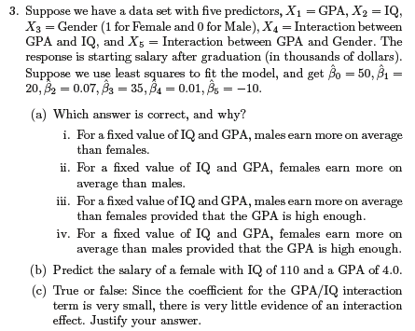**2.2.)**

**2.2.a.)**

Salary = 50 + 20*GPA + 0.07*IQ + 35*Gender + 0.01*GPA*IQ – 10*GPA*Gender

Statement iii is correct. If we take fixed values for IQ and GPA, the result of the following part of the formula will be same for both genders: 50 + 20*GPA + 0.07*IQ + 0.01*GPA*IQ.

The difference between the genders will become apparent in the following part of the formula: 35*Gender – 10*GPA*Gender. If we plug in different numbers for GPA, it becomes clear that both genders will earn the same if their GPA is at 3.5. If the GPA is higher, males earn more, and if it is lower, females will earn more.

**2.2.b.)**

Salary = 50 + 20*4 + 0.07*110 + 35*1 + 0.01*4*110 – 10*4*1 = 50 + 80 + 7.7 + 35 + 4.4 – 40

=127.1

The prediction for the salary of the graduate is approximately 127 thousand.

**2.2.c.)**

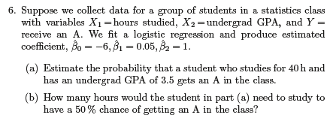**2.3.)**

**2.3.a.)**

Probability = -6 + 0.05*Study Hours + 1*Undergrad GPA

Probability = -6 + 0.05 * 40 + 1 * 3.5 = -6 + 2 + 3.5 = -0.5

It would be pretty impossible for him.

**2.3.b.)**

He would need to study 60 hours.

Probability = -6 + 0.05 * 60 + 1 * 3.5 = -6 + 3 + 3.5 = 0.5

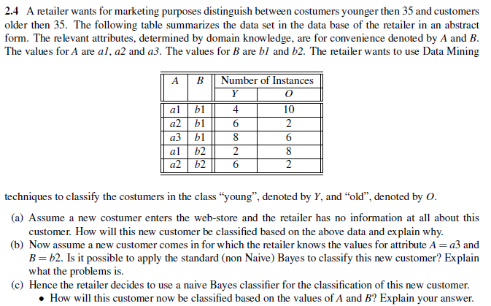**2.4.)**

**2.4.a.)**